Multiple-choice section – choose the correct answer

Question 1 [7.1]

For the triangle shown, which of the following represents the ratio  for the angle *a*?

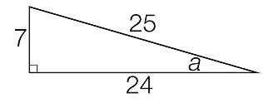

A B C D 

Question 2 [7.2]

If the sine ratio for the angle *b* = , the value of the unknown side *y* is:

**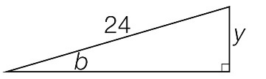**

A 3 B 9 C 15 D 27

Question 3 [7.3]

The value of *k* in the diagram would be found by using which equation?

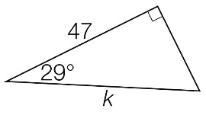

A sin(29°) =  B cos(29°) =  C tan(29°) =  D cos(29°) = 

Question 4 [7.5]

A 12.4 m power pole casts a shadow across the ground. If the angle of elevation of the sun is 37°, the length of the shadow is closest to:

A 7.5 m B 9.3 m C 15.5 m D 16.5 m

Question 5 [7.5]

A bearing of 214°T, written as a compass bearing, is:

A S14°W **B** S34°W **C** N34°W **D** S34°E

Question 6 [7.4]

The value of θ in the diagram is equal to which of the following expressions?

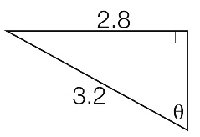

A  B  C  D 

Multiple-choice results: \_\_\_ / 6

Short answer section

Question 7 4 marks [7.3]

In an auditorium, a ramp is inclined at an angle of 12° from the ground to a stage at a height of 2.8 feet.

**(a)** Draw a diagram of the information provided.

**(b)** What is the length of the ramp to 1 decimal place?

Question 8 5 marks [7.5]

A bus travels 50 km on a bearing of N52°W.

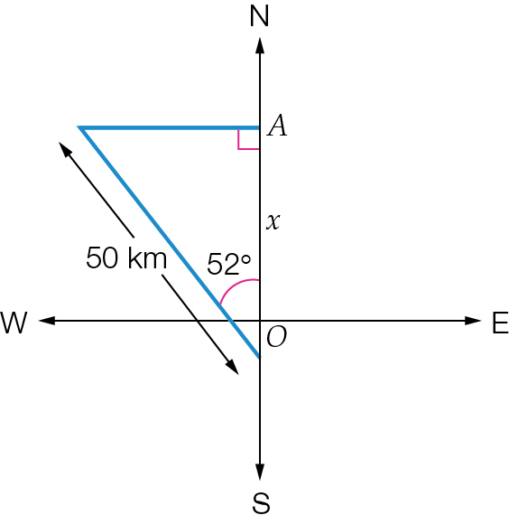

**(a)** How far north of its starting point is the bus?

**(b)** What is the true bearing equivalent to N52°W?

Question 9 5 marks [7.1]

A right-angled triangle has sides of length 5 cm, 12 cm and 13 cm.

**(a)** Draw a diagram of the triangle. Label the vertices *A*, *B* and *C*. Also label the right angle at *B* and the shortest side as *AB*. Mark the side lengths on the diagram, and label angle *CAB* as the reference angle θ.

**(b)** Label the sides O, A and H. Write the exact values for:

**(i)** sin θ

**(ii)** cos θ

**(iii)** tan θ

Question 10 6 marks [7.2]

Find the value of the unknown lengths, correct to 1 decimal place.

|  |  |  |
| --- | --- | --- |
| **(a)**  ACPM9_PR_7_07tsb | **(b)**  ACPM9_PR_7_08tsb_RR | **(c)**  ACPM9_PR_7_09tsb |

Question 11 6 marks [7.4]

Find the value of θ, correct to the nearest degree, in each of the following.

|  |  |  |
| --- | --- | --- |
| **(a)**  ACPM9_PR_7_10tsb | **(b)**  ACPM9_PR_7_11tsb | **(c)**  ACPM9_PR_7_12tsb |

Question 12 5 marks [7.2]

The adjacent side and hypotenuse of a triangle are 35 cm and 37 cm respectively.

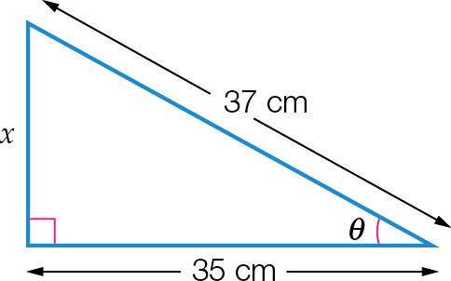

**(a)** Determine the opposite side in the triangle.

**(b)** Calculate the exact values of sin(θ), cos(θ) and tan(θ).

Question 13 3 marks [7.5]

The angle of elevation to the top of a mobile phone tower from a point 160 m from the base is 38°.

**(a)** Draw a diagram of the information provided.

**(b)** Find the height of the tower, correct to 1 decimal place.

Question 14 3 marks [7.3]

Find the perimeter of this semicircle, correct to 1 decimal place. Hint: The circumference of a circle can be found using *C* = 2π*r*.

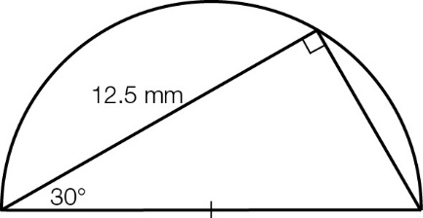

Short answer results: \_\_\_ / 37

Extended answer section

Question 15 7 marks [7.3, 7.4]

**(a)** The diagram below shows a section of a rectangular wall frame, constructed from wooden beams. Find the total length of wood needed for this section of the frame, correct to 2 decimal places.

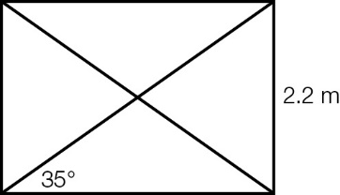

**(b)** The diagram below shows a triangular part of a roof frame. The ‘pitch angle’ θ is the angle that the sloping part of the roof makes with the horizontal. The frame is divided by a vertical beam into two symmetrical halves.

**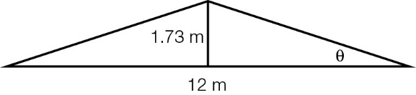**

**(i)** Find the pitch angle θ correct to 1 decimal place.

**(ii)** Find the total length of wood needed to build the section of frame shown.

Question 16 6 marks [7.5]

**(a)** Finn is standing 35 m away from the base of a tower and observes that the angle of elevation to the top of the tower is 25°. Calculate the height of the tower correct to 2 decimal places.

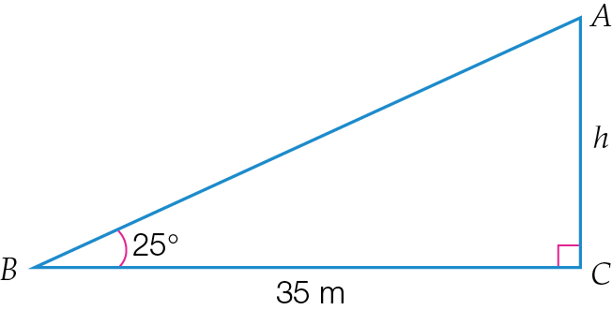

**(b)** What will be the angle of elevation, to the nearest degree, if he then moves 12 m towards the tower?

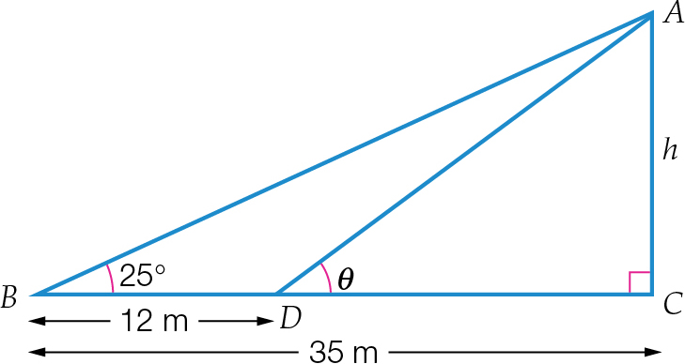

Extended answer results: \_\_\_ / 13

TOTAL test results: \_\_\_ / 56